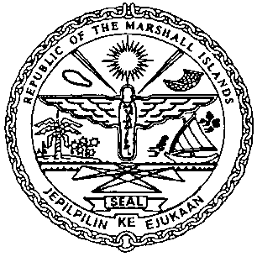 | REPUBLIC OF THE MARSHALL ISLANDS  MARITIME ADMINISTRATOR

MEMORANDUM OF PARTICULARS

RELEASE OF

Required Information | Response
Name of Vessel (and Hull Number if instrument is over a vessel under construction)
Official Number or IMO Number
Type of Instrument
Date of Instrument
Mortgagor Name
Mortgagee Name
Total Amount of Mortgage
Recording details of Mortgage Instrument(s) being released
Pre-signing Valid and Effective Clause (Identify clauses indicating the instrument shall only become valid and effective upon its recording with the Maritime Administrator, if applicable)
Intended Effect of the Instrument
Proof of Due Execution
(Indicate whether execution is verified by MI Special Agent/ Deputy Commissioner or Notarial Acknowledgment)

For and on behalf of [Name of Mortgagee]

By: ___________________________________________________
Name:
Title:

